Association for Computing Machinery (ACM) Delhi NCR Chapter organized its ‘Annual Day 2014’ on 1st November at Amity University, NOIDA. ACM was founded in 1947 and is the world's largest scientific and educational computing society.
The event featured a series of talks by eminent speakers on Modern Computer Science Challenges. The eminent guests included Prof. M. Balakrishnan (IIT Delhi), Dr. Sorav Bansal (IIT Delhi), Dr. Shweta Agarwal(IIT Delhi), Dr. Chetan Arora(IIIT Delhi), Rahul Bhalla (Co-founder, Zenatix).More than 120 students from different institutes across Delhi attended the event.
The event commenced with the lighting of the lamp by the dignitaries. Dr. Sorav Bansal (IIT-D) gave first session on topic “Virtualization and Cloud Computing”. He explained the term cloud computing in detail and also described various challenges faced in Virtualization. He told attendees about different applications of cloud computing like Backend as a Service (BaaS), Platform as a Service (PaaS) etc.
Rahul Bhalla (Co Founder, Zenatix) gave second session and he explained how we can understand our power consumption pattern and save electricity using energy analytics. He also discussed about a case study wherein just by using energy analytics, the company was able to save more than Rs.18 lakhs. Third Session was given by Dr. Shweta Agarwal (IIT Delhi) and the topic was “Bitcoins: Real or Virtual Money”. She explained what Bitcoins are and how they are fundamentally different from the currency that we are currently used to. Then she explained the different aspects related to virtual currency and also the transparency present in the Bitcoin because of its Open Source nature.
Dr. Chetan Arora (IIIT Delhi) gave the last session on the topic “Looking into the future with Google Glass: Opportunities and Challenges”. He explained the different challenges faced by ‘Egocentric Cameras’ and how to solve them. He discussed some research trends in this new exciting area with his recent work on temporal segmentation and privacy aware sharing of such egocentric videos.
Attendees were free to ask questions and clarify their doubts that made the sessions highly interactive and also helped in exchange of knowledge. Such exchange of information is useful for budding researchers and creates a conducive environment.

Glimpses of ACM Annual Day 2014

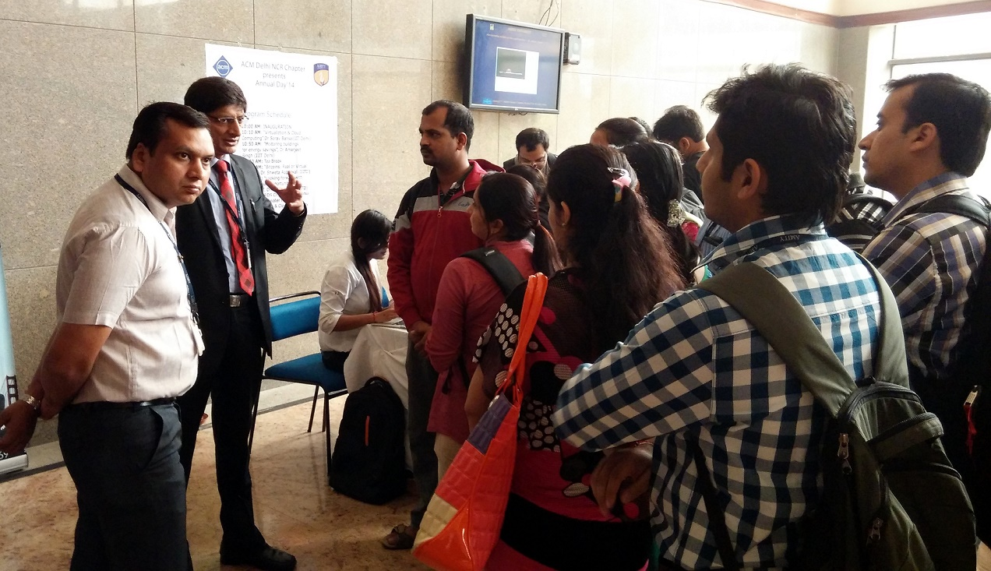

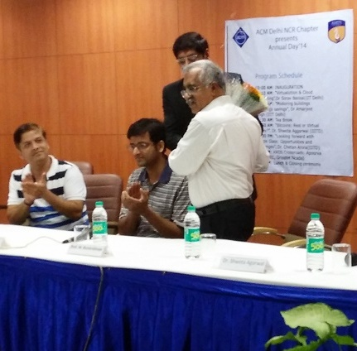

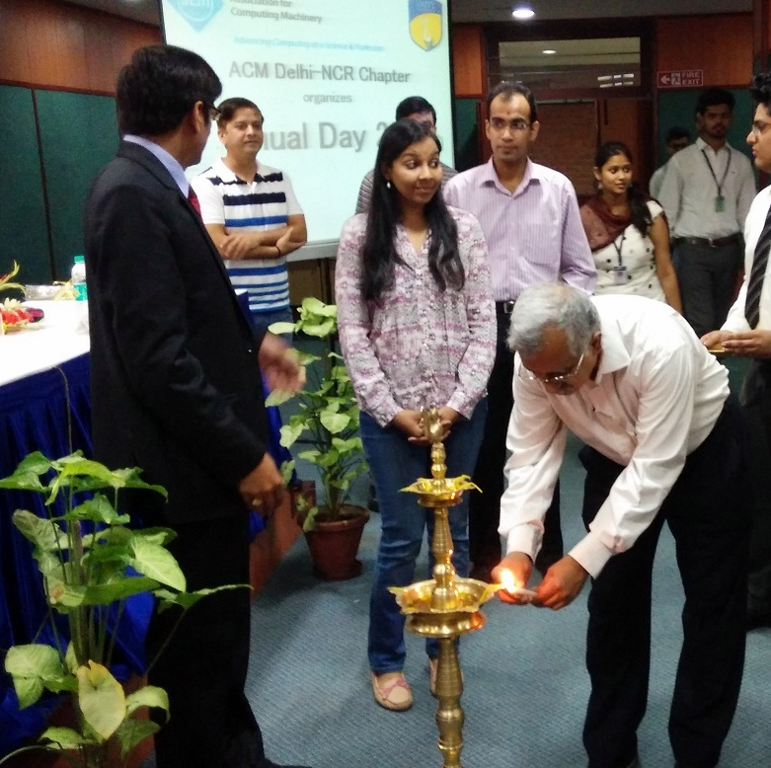
Lamp Lighting Ceremony

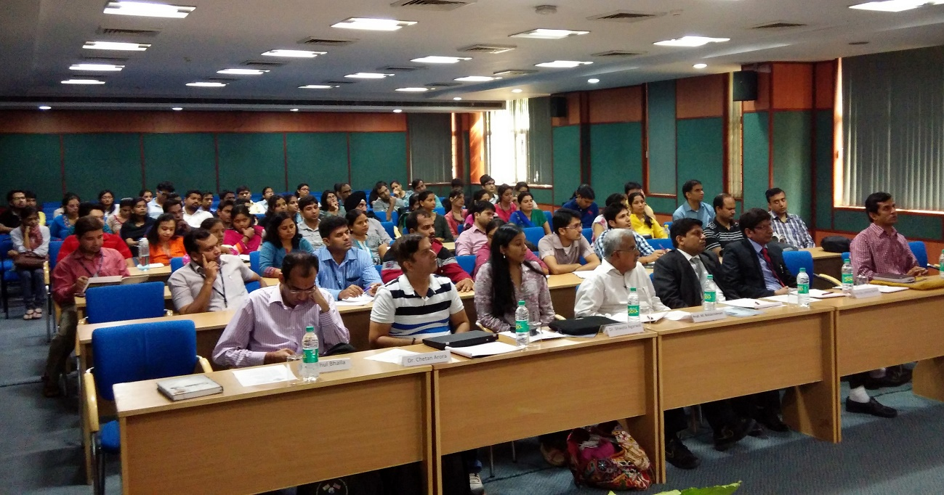
Participants in the expert session
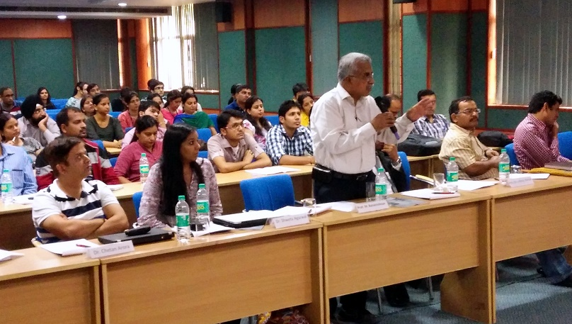
Questions and Answers after the session

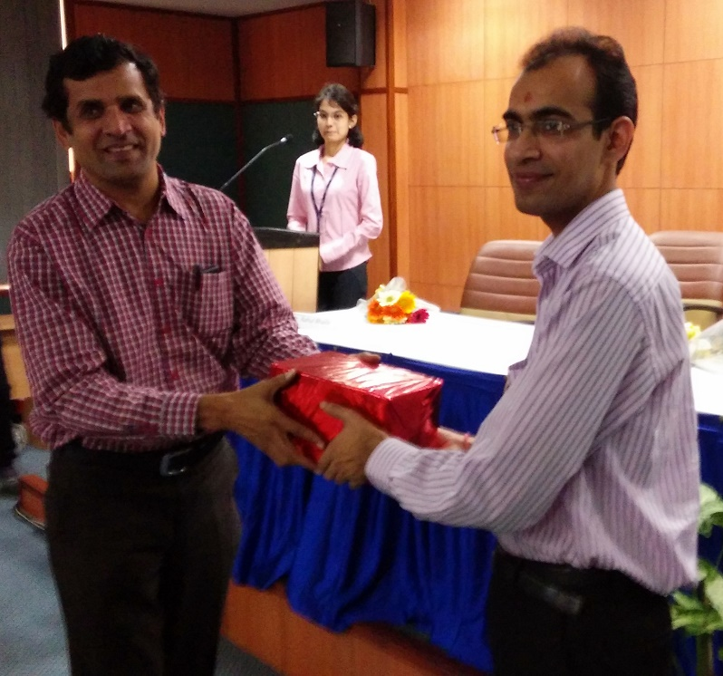
Token of Appreciation to the speakers
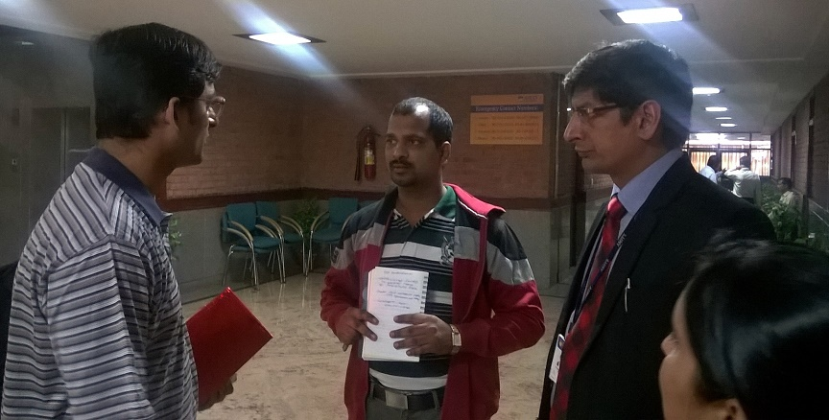
Speaker - Participant Interaction

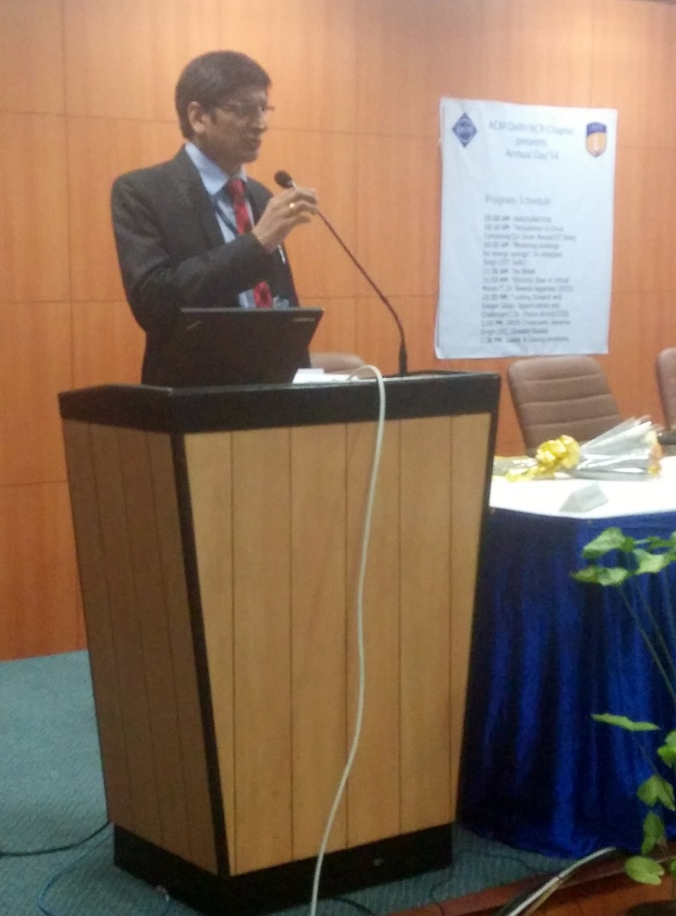
Vote of Thanks by Dr. Abhay Bansal
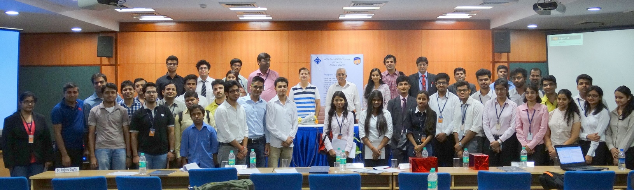
Amity ACM Student Chapter with the ACM Executive Body

